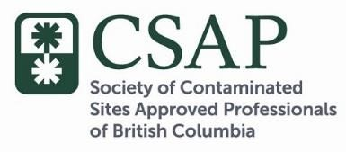

CSAP BOARD MEMO: Preparing for CSR Stage 10 Amendments

With the new CSR Stage 10 Amendment standards and guidance coming into effect November 1, 2017 the CSAP Board would like to draw our members’ attention to several important factors with respect to timing of submissions:

- Submissions that are determined to be “complete” (in compliance with all requirements for submission documents as outlined in Procedure 12) are considered to have been submitted on the date received at CSAP.

- The Ministry of Environment expects the AG 11 communications consultations to be complete and documented prior to a submission arriving at CSAP. As you know, AG 11 consultations may require up to 60 days. Accordingly, AG 11 activities should start by the end of August if you intend to make a submission for an off-site property prior to October 31^{st.} Please bear this in mind and advice any project teams you may be working with in regard to pending submissions that involve off-site properties.

- Submissions received at CSAP in advance of October 31st that do not comply with Procedure 12 will be considered incomplete and will be returned to the submitting AP. The revised submission package would need to be returned to CSAP in a complete state prior to October 31st to be eligible for evaluation against pre-Stage 10 Amendment requirements (i.e., standards and guidance). CSAP’s Transmittal letter summarizes the document requirements for a submission and we suggest use it so that your submission is accepted.

- Similarly, submissions received prior to October 31st that are selected for Performance
Assessment and that subsequently receive a ‘deficient’ finding after October 31st, would have to be revised to comply with Stage 10 Amendment requirements if resubmitted.

Based on feedback from APs, CSAP is expecting up to 140 submissions prior to November 1. It is highly recommended that submissions be made as early as possible as a large volume of submissions received in the final days leading up to October 31 will result in increased processing times. Further to this, we request that submissions be well organized and submitted in accordance with the CSAP Transmittal Letter to ensure processing delays are minimized.

Please review Ministry of Environment’s Bulletin 3 Application Submission: Contaminated Sites Regulation Omnibus Amendment Transition 2016-2017. CSAP will be closing at 5 pm on October 31st.

