CERTIFICATE OF COMPLIANCE
(Pursuant to Section 53 of the Environmental Management Act)

THIS IS TO CERTIFY that as of the date indicated below, the site identified in Schedule A of this Certificate of Compliance has been satisfactorily remediated to meet the applicable Contaminated Sites Regulation remediation standards and criteria.

This Certificate of Compliance is qualified by the requirements and conditions specified in Schedule B.

The substances for which remediation has been satisfactorily completed and for which this Certificate of Compliance is valid are listed in Schedule C.

I have issued this Certificate of Compliance based on a review of relevant information including the documents listed in Schedule D. I, however, make no representation or warranty as to the accuracy or completeness of that information.

A Director may rescind this Certificate of Compliance if requirements and conditions imposed in the Certificate of Compliance are not complied with or any fees payable under Part 4 of the Act or regulations are outstanding.

This Certificate of Compliance should not be construed as an assurance that there are no hazards present at the site.

Schedule A

The site covered by this Certificate of Compliance is located at 13576 King George Boulevard, Surrey, British Columbia which is more particularly known and described as:

Lot A, Except: Parcel 2 (Reference Plan 31517), Section 15, Block 5 North, Range 2 West, New Westminster District Plan 7559

PID: 004-265-335

The approximate centre of the site using the NAD (North American Datum) 1983 convention is:

Latitude: | 49° | 11' | 57.50"
Longitude: | 122° | 50' | 48.30"

Site Plan
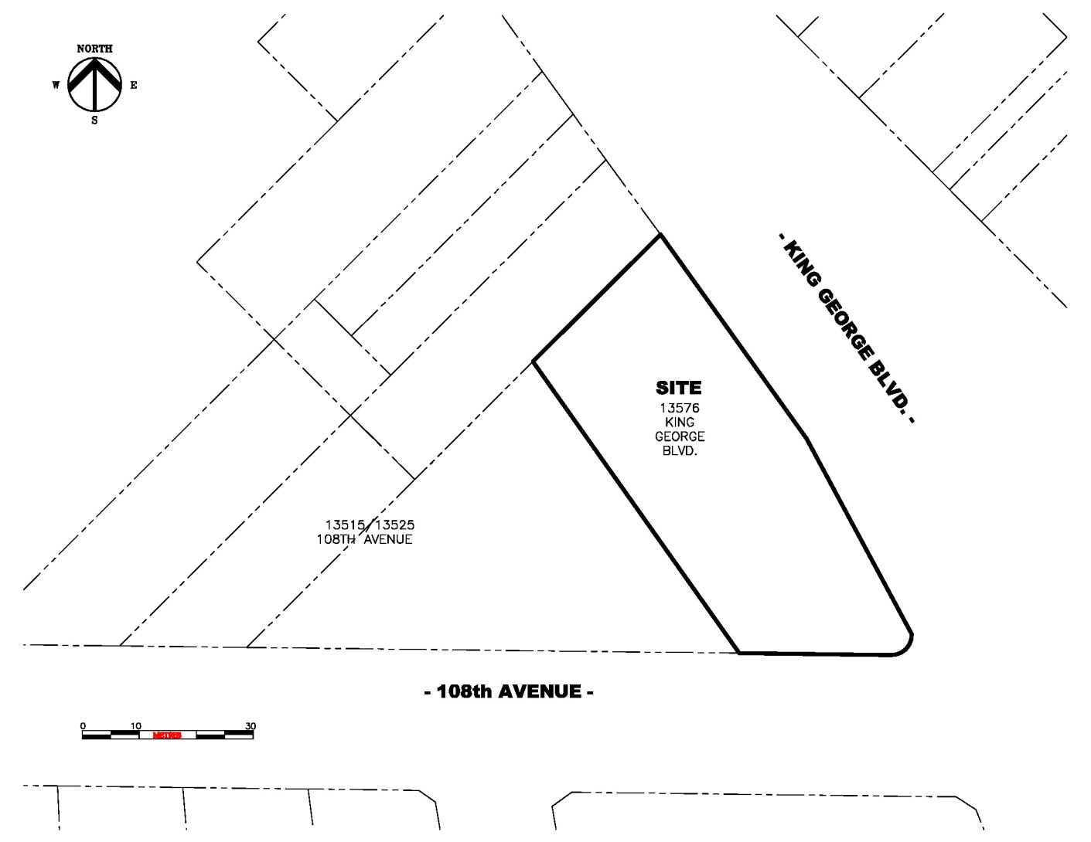

Location Map
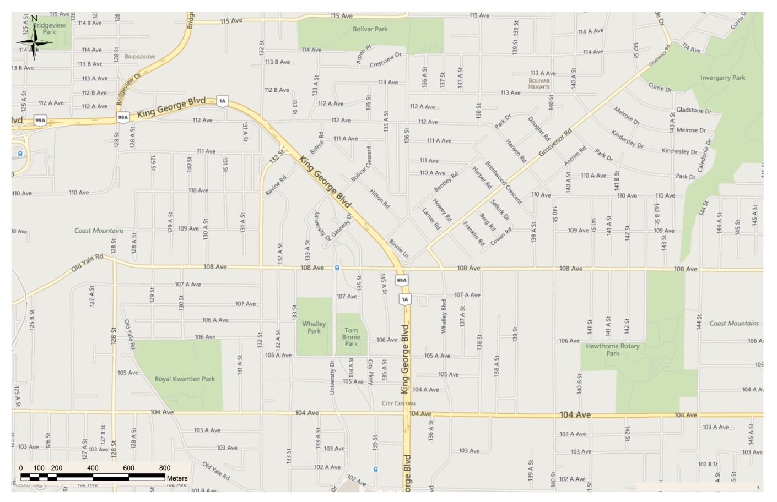
Site
Schedule B

Requirements and Conditions

- Any changes in land, vapour, or water uses must be promptly identified by the responsible person in a written submission to the Director. An application for an amendment or new Certificate of Compliance may be necessary. The uses to which this condition applies are described in Schedule C and in the site investigation documents listed in Schedule D.

The documents listed in Schedule D indicate that vapour attenuation factors were applied to meet Contaminated Sites Regulation numerical standards at the site. These vapour attenuation factors were selected based on assumptions about the structures, locations and depths of buildings and trenches existing or expected at the site. These assumptions include the following:
- The land use at the site will be commercial and all buildings will be of slab-on-grade construction.
- Grade will remain approximately consistent with current grade or higher.
- A worker health and safety plan with provisions to prevent inhalation exposures must be developed in the event that trenches (excavations that are deeper than they are wide, > 1.5 m bgs suitable for human entry) are advanced at the site.
Any inconsistencies that arise between the structures, locations and depths of proposed or constructed buildings or trenches at the site and the range of structures, locations and depths of buildings or trenches assumed in the selection of vapour attenuation factors in the documents listed in Schedule D must be promptly identified by the responsible person in a written submission to the Director. An application for an amendment or new Certificate of Compliance may be necessary.

Schedule C

Substances and Uses

Substances remediated in soil for commercial land soil use:

To meet numerical remediation standards:

- Benzene, ethylbenzene, toluene, and xylene; and
- VPHs, and HEPHs.

Substances remediated in vapour for commercial land vapour use:

To meet numerical remediation standards:

- Benzene, and VPHv.

Substances remediated in water for freshwater aquatic life water use:

To meet numerical remediation standards:

- Benzene, and toluene;
- VHw₆₋₁₀, VPHw, and LEPHw; and
- Naphthalene.

Schedule D

Documents

Summary of Site Condition (Site ID: 40), SNC-Lavalin Inc., January 29, 2016;

Addendum, Certificate of Compliance Submission, 13576 King George Boulevard, Surrey, BC and Management Areas (CSAP PA Reference #: PA 15-034; MoE Site ID: 40), SNC-Lavalin Inc., January 21, 2016;

Summary of Communication in Regards to the Certificate of Compliance Application for the City of Surrey Management Area (MA-A) and a Portion of 13515 and 13525 – 108th Avenue, Surrey, BC (MA-B) Associated with the Property Located at 13576 King George Boulevard, Surrey, BC (MoE Site ID: 40), SNC-Lavalin Inc., July 9, 2015;

Stage 1 Preliminary Site Investigation Addendum, Detailed Site Investigation, Remedial Excavation and Post-Excavation Investigation Report, 13576 King George Boulevard, Surrey, BC, SNC-Lavalin Inc., June 2, 2015;

Stage 1 Preliminary Site Investigation, Petro-Canada Former Service Station, 13576 King George Highway, Surrey, BC, SNC-Lavalin Inc., March 27, 2003;

Remediation Progress Report 8 (1998 05 07 to 1999 03 30) Former Petro-Canada Service Station 108th Avenue and King George Highway, Surrey, BC, BC ELP File No. AS-13452 and Permit No. PS-14631, SNC-Lavalin Inc., October 27, 1999;

Remediation Progress Report 7 (1998 02 16 to 1998 05 06) Former Petro-Canada Service Station 108th Avenue and King George Highway, Surrey, BC, BC ELP File No. AS-13452 and Permit No. PS-1463, SNC-Lavalin Inc., May 27, 1998;

Remediation Progress Report 6 (1997 09 02 to 1998 01 16) Former Petro-Canada Service Station 108th Avenue and King George Highway, Surrey, BC, BC ELP File No. AS-13452 and Permit No.: PS-1463, SNC-Lavalin Inc., March 6, 1998;

Remediation Progress Report 5 (1997 03 16 to 1997 07 17) Former Petro-Canada Service Station 108th Avenue and King George Highway, Surrey, BC, BC ELP File No. AS-13452 and Permit No.: PS-1463, SNC-Lavalin Inc., July 24, 1997;

Request to De-list 800 m3 of Special Waste Soil from the Stage 6 Excavation at the Former Petro-Canada Service Station, 108th Avenue & King George Highway, Surrey, BC, BC ELP Permit No. PS-14631, SNC-Lavalin Inc., July 3, 1997;

Remediation Progress Report 4 (1996 04 30 to 1996 11 28) Former Petro-Canada Service Station 108th Avenue and King George Highway, Surrey, BC, BC ELP File No. AS-13452 and Permit No. PS-14631, SNC-Lavalin Inc., January 10, 1997;

Request to De-list 1,100 m3 of Special Waste Soil From the Stage 5 Excavation at the Former Petro-Canada Service Station, 108th Avenue & King George Highway, Surrey, BC, BC ELP Permit No. PS-14631, SNC-Lavalin Inc., November 28, 1996;

Request to De-list 420 m3 of Former Special Waste Soil Currently in Storage at the Former Petro-Canada Service Station, 108th Avenue & King George Highway, Surrey, BC, BC ELP File No. AS-13452, SNC-Lavalin Inc., August 15, 1996;

Remediation Progress Report 3 (1995 10 25 to 1996 04 29) Former Petro-Canada Service Station 108th Avenue and King George Highway, Surrey, BC, BC ELP File No. AS-13452, SNC-Lavalin Inc., June 4, 1996;

Remediation Progress Report 2 (1995 06 29 to 1995 10 24) Former Petro-Canada Service Station 108th Avenue and King George Highway, Surrey, BC, BC ELP File No. AS-13452, SNC-Lavalin Inc., December 5, 1995;

Remediation Progress Report 1 (1995 03 29 to 1995 06 29) Former Petro-Canada Service Station 108th Avenue and King George Highway, Surrey, BC, BC ELP File No. AS-13452, SNC-Lavalin Inc., July 25, 1995;

Request for Approval to Store and Treat Hydrocarbon Contaminated Soils, Former Petro-Canada Service Station 13576 King George Highway, Surrey, BC, SNC-Lavalin Inc., October 26, 1994;

Progress Report 6, Petro-Canada Service Station, 108th Avenue & King George Highway, Surrey, BC, SNC-Lavalin Inc., September 27, 1994;

Petro-Canada Service Station, 108th Avenue and King George Highway, Surrey, BC, SNC-Lavalin Inc., December 6, 1991;

Petro-Canada Service Station, 108th Avenue and King George Highway, Surrey, BC, SNC-Lavalin Inc., July 11, 1991;

Petro-Canada Service Station, 108th Avenue and King George Highway, Surrey, BC, SNC-Lavalin Inc., April 22, 1991;

Petro-Canada Service Station, 108th Avenue and King George Highway, Surrey, BC, SNC-Lavalin Inc., February 14, 1991;

Petro-Canada Service Station, 108th Avenue and King George Highway, Surrey, BC – Environmental Assessment, SNC-Lavalin Inc., February 23, 1990;

Petro-Canada Service Station, 108th Avenue and King George Highway, Surrey, BC, SNC-Lavalin Inc., February 22, 1990; and

Petro-Canada Service Station, 108th Avenue and King George Highway, Surrey, BC, SNC-Lavalin Inc., July 28, 1989.

